Deciding what to try next

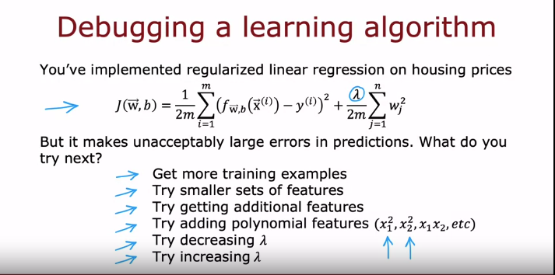
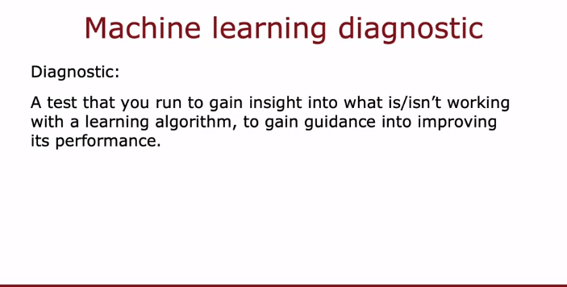
Introduction to Efficient Machine Learning:
  - Building a machine learning system efficiently is crucial, and skilled teams can achieve significant results in a shorter time frame.
- Making Decisions in ML Projects:
  - The efficiency of a machine learning project depends on making informed decisions throughout the process.
- Tips on Decision-Making:
  - The goal is to share tips on how to make effective decisions in a machine learning project, saving time and resources.
- Example Scenario - Regularized Linear Regression:
  - Consider a scenario where regularized linear regression is used to predict housing prices with a cost function that includes squared error and a regularization term.
- Addressing Prediction Errors:
  - If the model produces large prediction errors, various strategies can be considered to improve its performance.
- Different Approaches to Try:
  - Options include acquiring more training data, reducing the number of features, adding new features, experimenting with polynomial features, and adjusting regularization parameters.
- Importance of Wise Choices:
  - Making effective decisions about where to invest time is crucial in the machine learning process.
- Diagnosing Model Performance:
  - Learning how to carry out diagnostics is essential to gain insights into what is or isn't working in the learning algorithm.
- Diagnostic Tests:
  - Diagnostics serve as tests to understand the performance of the learning algorithm and guide improvements.
- Time Investment Consideration:
  - Teams sometimes spend a significant amount of time collecting more training data, but the effectiveness of this investment varies. Diagnostics can help determine if it's worthwhile.
- Focus on Efficiency:
  - Running diagnostics can take time to implement but can be a valuable use of time in the long run for improving algorithm performance.
- Upcoming Content:
  - The upcoming week will cover various diagnostics that provide insights and guidance for improving learning algorithm performance.

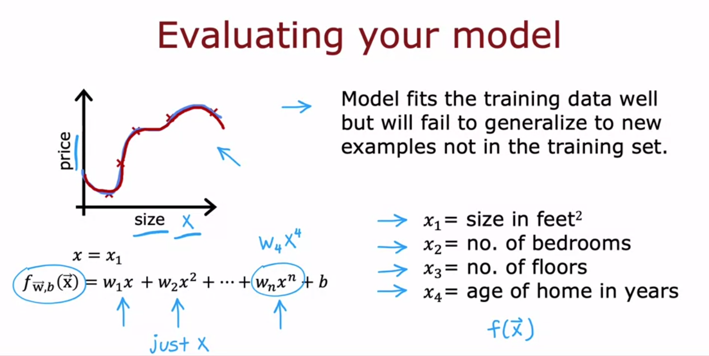
Evaluating and Choosing a Model
- Importance of Evaluating Model Performance:
  - Evaluating the performance of a machine learning model is crucial for understanding its effectiveness and identifying areas for improvement.
- Example Scenario - Predicting Housing Prices:
  - Consider a scenario where the goal is to predict housing prices based on the size of the house (feature "x").
  - A fourth-order polynomial model is trained using features x, x squared, x cubed, and x to the power of 4.
- Over fitting and Generalization Concerns:
  - The trained model fits the training data well, but there are concerns about its ability to generalize to new examples not in the training set.
  - Over fitting occurs when a model is too complex and captures noise in the training data.
- Visualization Challenges with Multiple Features:
  - Visualizing the model's performance becomes challenging when there are multiple features (x1, number of bedrooms, number of floors, age of the home).
- Need for Systematic Evaluation:
  - A systematic way to evaluate model performance is essential, especially when dealing with multiple features that make it difficult to visualize the model.
- Introduction to Systematic Evaluation Methods:
  - There is a need for a more systematic way to evaluate how well the model is performing.
  - This is particularly important for applications with multiple features where plotting the model becomes impractical.
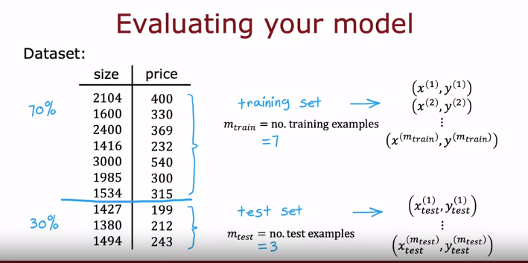
- Need for Systematic Evaluation with Multiple Features:
  - When dealing with applications having more than one or two features, it becomes challenging to visually plot the model's performance using traditional methods.
- Introduction to Systematic Evaluation Technique:
  - To systematically evaluate the model's performance, a technique is introduced.
  - Instead of using the entire training set to train the model's parameters w and b, the training set is split into two subsets: a training set (70% of the data) and a test set (30% of the data).
- Training and Testing Process:
  - The model's parameters are trained on the first part (training set) of the data.
  - The model's performance is then tested on the second part (test set) to evaluate how well it generalizes to new, unseen examples.
- Notation for Training and Test Sets:
  - Training examples are denoted as x1​,y1​,…,xm​,ym​ for both the training and test sets.
  - Subscripts are introduced to distinguish between training and test sets, using mtrain​ and mtest​ to represent the number of examples in each set.
- Common Split Ratios:
  - It is common to split the dataset into training and test sets using ratios like 70:30 or 80:20.
  - The majority of the data goes into the training set, with a smaller fraction allocated to the test set.

Train/Test Procedure for linear regression (with squared error cost)
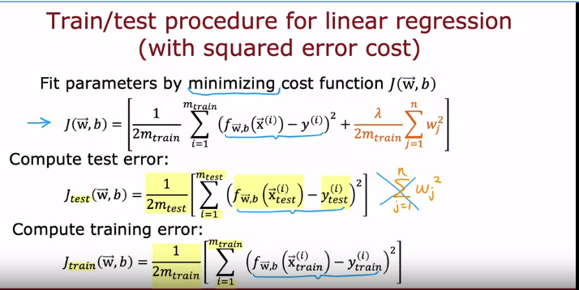
- Training and Evaluation in Linear Regression:
  - When using linear regression with a squared error cost function, the goal is to fit the parameters by minimizing the cost function J(w,b).
  - The cost function includes the square error cost and a regularization term.
- Cost Function in Linear Regression:
  - The cost function J(w,b) is given by the sum of squared errors plus a regularization term.
- Evaluation on Test Set:
  - To assess how well the model is performing, Jtest​(w,b) is computed.
  - Jtest​(w,b) is the average error on the test set, computed as the sum of squared errors on each test example.
- Test Error Formula:
  - The regularization term is not included in the test error formula.
- Useful Quantity - Training Error:
  - Another useful quantity to compute is the training error.
  - The training error measures how well the learning algorithm is performing on the training set.
This process involves minimizing the cost function during training and then evaluating the model's performance on the test set using the test error formula. The training error is also computed to understand the algorithm's performance on the training set
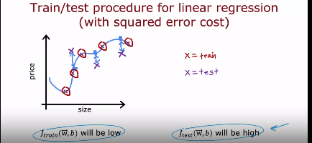
Training Error Jtrain​(w,b):
  - In a well-fitted model, the training error (Jtrain​) will be low because the model has been trained on the training set, and the average error on those examples is close to zero.
- Test Error Jtest​(w,b):
  - However, if there are additional examples in the test set that the model has not been trained on, the test error (Jtest​) might be high.
  - The model's predictions for these new examples may have a significant gap from the actual values of the target variable.
- Gap Between Predictions and Actual Values:
  - The presence of a large gap between the model's predictions and the actual values in the test set indicates that the model is not generalizing well to new, unseen examples.
- High Jtest​ Indicates Poor Generalization:
  - A high test error (Jtest​) suggests that the model, while performing well on the training set, is not effective at generalizing to new data points outside the training set.
- Importance of Generalization:
  - Generalization is a key aspect of a machine learning model's performance, reflecting its ability to make accurate predictions on data it has not seen during training.
- Understanding Model Behavior on New Examples:
  - The test error provides insights into how well the model generalizes to new data points, emphasizing the importance of evaluating performance beyond the training set.
In summary, a high test error indicates that the model may not be suitable for making accurate predictions on new, unseen examples, highlighting the need for improvements in generalization.

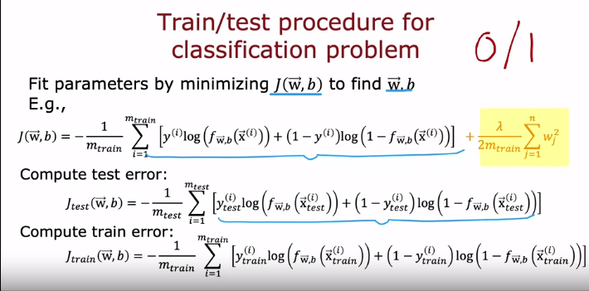
Classification Problem and Logistic Regression:
  - In the context of a classification problem, such as distinguishing between handwritten digits 0 or 1, logistic regression is commonly used.
  - The goal is to fit the parameters (w,b) by minimizing the cost function.
- Cost Function for Logistic Regression:
  - For logistic regression, the cost function (J(w,b)) consists of the logistic loss function plus a regularization term.
  - The logistic loss function measures the difference between predicted and actual classes.
- Test and Training Error for Classification:
  - To compute the test error (Jtest​), average the logistic loss over the test set (30% of data not in the training set).
  - The training error (Jtrain​) is computed similarly using the logistic loss over the training data used for parameter optimization.
- Alternative Definition of Errors in Classification:
  - In classification problems, an alternative and commonly used definition of Jtest​ and Jtrain​ is to measure the fraction of misclassified examples.
  - Instead of using the logistic loss, this approach directly counts and reports the misclassification rate on the test and training sets.
- Misclassification Rate:
  - The misclassification rate is the proportion of examples in the set that were incorrectly classified by the algorithm.
- Evaluation Beyond Logistic Loss:
  - While logistic loss provides a measure of how well the model aligns with the true class probabilities, misclassification rates offer a more straightforward measure of classification accuracy.
- Commonly Used Definition in Classification:
  - For classification problems, assessing performance based on misclassification rates is a common and intuitive approach.
In summary, for classification problems, the evaluation of model performance involves computing test and training errors using the logistic loss or directly measuring the fraction of misclassified examples, providing insights into the accuracy of the classification algorithm.

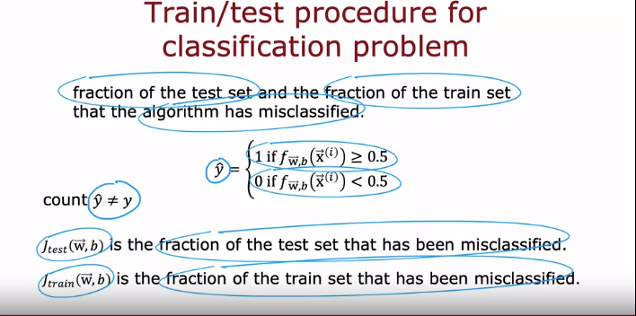
- Misclassification Rate as an Alternative Metric:
  - Instead of using the logistic loss to compute test and training errors, an alternative approach is to measure the fraction of misclassified examples in the test set and training set.
- Prediction Using Threshold:
  - For the test set, predictions (yhat​) are made based on a threshold. For example, predict 1 if f(x)≥0.5 and predict 0 if f(x)<0.5.
- Counting Misclassifications:
  - Count the fraction of examples in the test set where yhat​ is not equal to the actual ground truth label.
- Concrete Example for Binary Classification:
  - In a binary classification task (e.g., classifying handwritten digits 0 or 1), Jtest​ represents the fraction of the test set where 0 was classified as 1 or 1 was classified as 0. Jtrain​ is similarly calculated for the training set.
- Systematic Evaluation with Training and Test Sets:
  - Splitting the dataset into a training set and a separate test set enables systematic evaluation of the learning algorithm's performance.
  - Jtest​ and Jtrain​ provide insights into misclassifications on the test and training sets, respectively.
- Automated Model Selection:
  - The procedure of evaluating Jtest​ and Jtrain​ is a step towards automatically choosing the most suitable model for a given machine learning application.

Model selection and training cross validation/test sets
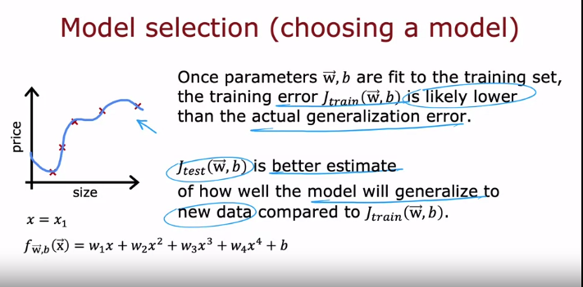
- Refinement to Model Evaluation:
  - The goal is to make a further refinement to the idea of using the test set to evaluate the performance of a model.
- Challenge with Training Error:
  - Training error may not be a good indicator of how well a model will generalize to new, unseen examples.
  - After fitting the model's parameters (w and b) to the training set, the training error may be very low (even close to zero).
- Generalization Error:
  - Generalization error refers to the average error on new examples that were not part of the training set.
  - The goal is to find a better indicator of how well the model will likely perform on new data not seen during training.
- Importance of Jtest​:
  - Jtest​, which measures the performance of the algorithm on examples not used for training, provides a better indicator of generalization performance.
  - It reflects how well the model is likely to perform on new data beyond the training set.
- Choosing a Good Model:
  - The refined idea is to use the technique to automatically choose a good model for the machine learning algorithm.
  - This involves evaluating different models using Jtest​ to select the one that performs well on unseen examples.
- Emphasis on Generalization Performance:
  - The focus is on assessing the model's ability to generalize, emphasizing the importance of evaluating performance on examples not present in the training set.
This refinement underscores the significance of using Jtest​ as a key metric for model evaluation and selection, especially when aiming for good generalization performance on new and unseen data.
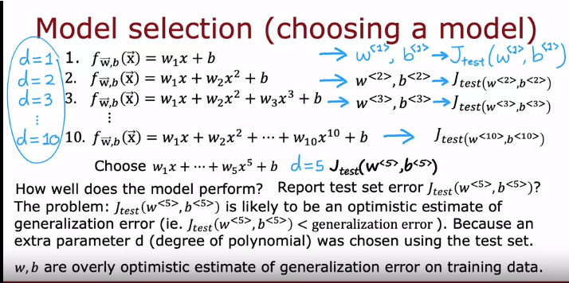
Choosing the Model:
- fitting various polynomial models of different degrees (linear, quadratic, cubic, etc.) to the training data.
- Each model has its own set of parameters (w and b).
- We evaluate each model's performance on the test set using the J_test metric.
- The model with the lowest J_test is considered the best.
Problem with this Approach:
- This approach is flawed because it chooses the model based on the test set.
- Using the test set for model selection leads to over-fitting, meaning the model performs well on the test set but may not generalize well to unseen data.
Better Approach:
- Introduce a separate validation set for model selection.
- Train the models on the training set.
- Evaluate each model's performance on the validation set.
- Choose the model with the best performance on the validation set.
- Finally, evaluate the chosen model on the test set to get an unbiased estimate of its generalization error.
Key Takeaways:
- Don't use the test set for model selection to avoid over-fitting.
- Always use a separate validation set for choosing the best model.
- The final evaluation of the chosen model should be done on the test set.
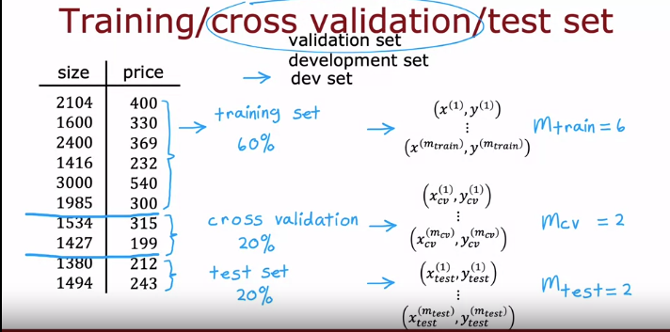
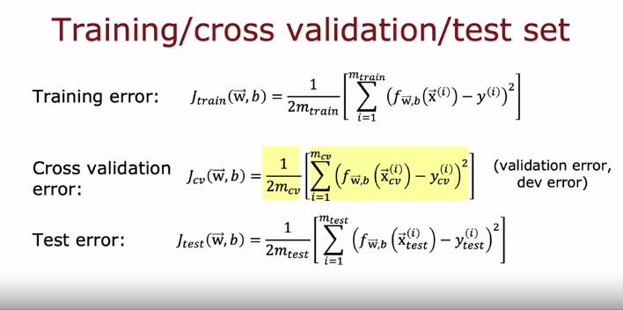
- Error Computation on Subsets:
  - After splitting the data into training set, cross-validation set, and test set, you can compute errors for each subset using the following formulas:
    - Training Error
    - Cross-Validation Error
    - Test Error
  - None of these terms include the regularization term.
- Cross-Validation Error Term:
  - The term Jcv​ represents the average squared error over the cross-validation examples.
  - This term is also referred to as:
    - Validation Error: A short form for cross-validation error.
    - Development Set Error: Another term used to describe the error on the cross-validation set.
    - Dev Error: A shortened version of development set error.
In summary, training error, cross-validation error, and test error can be computed on their respective subsets of the data, and the term Jcv​ serves as both the cross-validation error and may be referred to by alternative names such as validation error, development set error, or dev error.
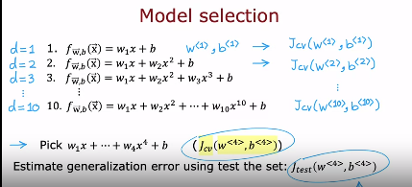
1. Training Models:
- Train 10 different polynomial models with degrees ranging from 1 to 10.
- Fit the parameters (w and b) for each model on the training set.
2. Evaluating on Cross-Validation Set:
- Evaluate each model's performance on the cross-validation set using the cross-validation error (J_cv).
3. Choosing the Best Model:
- Select the model with the lowest cross-validation error.
- In the example, the fourth-order polynomial (d = 4) has the lowest J_cv, so it's chosen.
4. Estimating Generalization Error:
- Evaluate the chosen model (the fourth-order polynomial with w4 and b4) on the test set to get an unbiased estimate of its generalization error (J_test).
5. Key Points:
- The test set is not used for model selection or parameter tuning, ensuring an unbiased estimate of generalization error.
- The cross-validation set guides model selection, preventing over fitting to the test set.
- This model selection procedure applies to various types of models, not just polynomial regression.

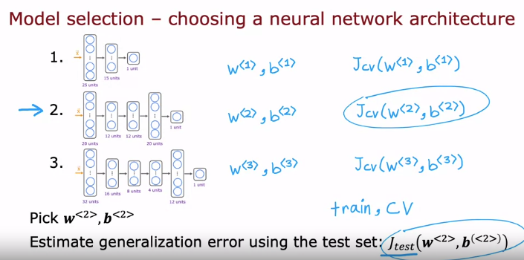
Choosing a Neural Network Architecture:
- Consider multiple models with different architectures (small, medium, large).
- Train each model on the training set and obtain parameters (w, b).
- Evaluate each model's performance on the cross-validation set using J_cv (classification error in this case).
- Choose the model with the lowest cross-validation error.
- Evaluate the chosen model on the test set to estimate generalization error (J_test).
Key takeaway:
- Similar to polynomial regression, cross-validation helps choose the best neural network architecture without compromising the test set.
- This prevents overfitting and provides a more reliable estimate of how well the model generalizes to unseen data.
Best Practices:
- Make all decisions (model parameters, architecture) using only the training and cross-validation sets.
- Use the test set only for final evaluation after choosing the model.
- This ensures an unbiased and generalizable estimate of model performance.
Importance of Model Selection:
- This is a widely used procedure for choosing models in machine learning.
- It automates model selection and can be applied to various algorithms.

